**PRESS RELEASE**

**COMMUNICATIONS AND MEDIA TEAM OF THE 2023 ASEAN SUMMIT**

**No.62/SP/TKM-ASEAN2023/ENG/5/2023**

**Indonesia, Vietnam Agree on Cooperation on Digital Space Utilization for ASEAN**

**West Manggarai, 10 May 2023** **–** Indonesia and Vietnam agreed on cooperation on digital literacy and utilization of digital space. The cooperation shall provide benefits for people in the Southeast Asian region (ASEAN).

Minister of Communications and Informatics of the Republic of Indonesia Johnny G. Plate made the statement after a bilateral meeting with the Minister of Information and Communications of Vietnam Nguyen Manh Hung at the Jayakarta Hotel in Labuan Bajo, West Manggarai Regency, East Nusa Tenggara, Wednesday (10 May).

The meeting was held during the 42nd ASEAN Summit in Labuan Bajo. “The ASEAN region has the potential with strong digital technology growth. A great potential that continues to grow,” said Johnny after the meeting.

On the occasion, both parties also shared their experiences in the development and use of information and communication technology, especially in handling hoaxes, disinformation, and cybercrimes.

“Both countries also agreed on the importance of formulating a joint legal umbrella for the development of digital space, including in ASEAN. For Indonesia and Vietnam, a Memorandum of Understanding (MoU) is agreed and serves as the initial framework for cooperation,” said Minister Johnny, adding that Indonesia and Vietnam also emphasized the importance of law enforcement in the digital space.

“Cooperation and collaboration in ASEAN are necessary to combat cybercrimes,” he said.

Moreover, according to Johnny, both parties agreed to support law enforcement against trafficking-in-persons, especially the ones committed through cybercrimes.

“Vietnam and Indonesia, as two countries with large populations in ASEAN share similar perspective on enhancing ASEAN’s economy, particularly in digital space and digitization, including law enforcement in this field,” said the Minister.

Meanwhile, Vietnamese Minister Nguyen Manh Hung considered the cooperation between the two states important and must be strengthened.

He explained that Vietnam is planning to realize the MoU between the two ministries as the basis of cooperation by September 2023.

“The next step is a long-distance partnership between the two countries and two ministries. I think that we have a lot in common to work together, especially since this is not only for the benefit of the two countries, but the ASEAN region,” he said. (InfoPublik/TR/Elvira/WW/PPR)

***

For more information, please contact:

**Director General of Public Information and Communications of the Ministry of Communications and Informatics – Usman Kansong (0816785320).**

Get more information at <http://asean2023.id>, <https://infopublik.id/kategori/asean-2023>, and <https://indonesia.go.id/kategori/ragam-asean-2023>

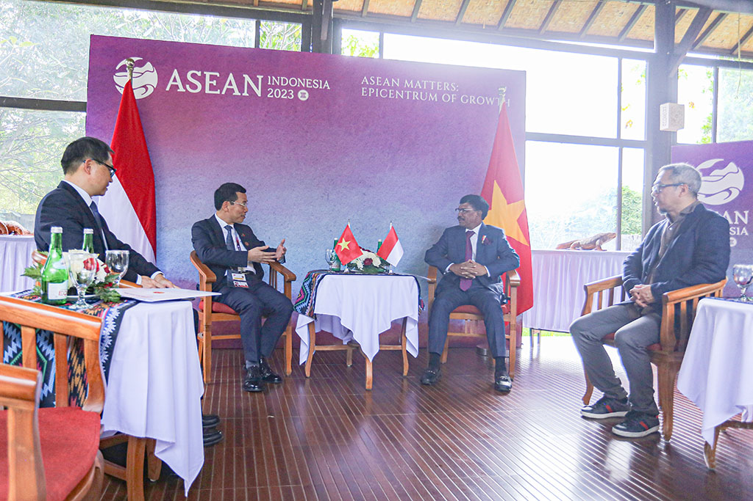

Minister of Communications and Informatics of the Republic of Indonesia Johnny G. Plate receives a visit from the Minister of Information and Communication of Vietnam during the 42nd ASEAN Summit 2023 in Labuan Bajo, Manggarai Regency, East Nusa Tenggara, Wednesday (10 May 2023).

(InfoPublik/Agus Siswanto)